KSS
PUBLIC HEALTH ARCP GUIDE
Contents
ARCP: What is its Purpose? 2
Pre-ARCP 3
During ARCP 7
Post-ARCP checklist 8
ARCP Outcomes 9

Created March 2025 by Claire Elwick and Amy Hooper
To be reviewed March 2027

ARCP: What is its Purpose?
ARCP: Annual Review of competency Progression
The ARCP provides a formal process that reviews the evidence presented by the Specialty Registrars in training and their educational supervisor relating to their progress against the objectives defined in the curriculum. It enables the Specialty Registrars in training, the Postgraduate Dean and employers to document that the capabilities required are being gained at an appropriate rate and through appropriate experience.
See the Gold Guide 10th Edition from August 2024 HERE Pg 63 – ARCP for further information and details
Most ARCP’s are held between the 1st week of June and the first week of July, unless you are out of sync or expecting a pre-maternity ARCP.
StR should receive an ARCP invite a minimum of 8 weeks before the ARCP Date. The school will aim to send this invite out 10-12 weeks before the ARCP allowing adequate time to prepare documentation. All documentation is usually required to be submitted 2 weeks before the ARCP date. This should give a minimum of 6 weeks to prepare for ARCP. StRs are not expected to attend ARCP Panel, they may receive a calendar invite for date information only.
The ARCP email invite should state the following information:
- Date of ARCP
- List of documentation required
- Deadline for submission date
It should also include any template documents that may be required such as
- Pre ARCP meeting summary form
- Educational Supervisor report,
- Learning Agreement form,
- Curriculum progress review form,
- Time out of training (TOOT) further information form (if more than the 14 day TOOT allowance has been taken within the training year)
- CCT Calculator (if any changes to your CCT date has been made through TOOT such as sick leave, out of placement (OOP), or Parental leave. Most CCT calculators will have been issued when OOP/Parental leave etc. has been agreed and approved.)

Pre-ARCP
  - The necessary forms
The following forms are needed for all trainees:
- Form R
- Pre ARCP meeting summary form
- Educational Supervisor report,
- Learning Agreement form,
- Curriculum progress review form
Additional forms (only if needed):
- TOOT further information form (if more than the 14 day TOOT allowance has been taken within the training year)
- CCT Calculator (if any changes to your CCT date has been made through TOOT such as sick leave, OOP, or Parental leave. Most CCT calculators will have been issued when OOP/Parental leave etc. has been agreed and approved.)
  - Guidance on forms
1. Educational Supervisor reports
You need to provide a supervisor report for each placement since your previous ARCP (or if your 1st ARCP, all placements since commencing training).
2. Learning Agreement Form:
There should be 1 form per placement, but we will accept 1 per training year if appropriate (i.e., long placement)
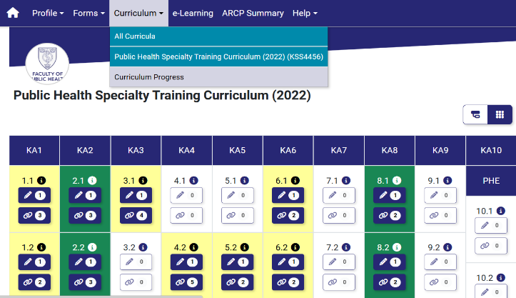
3. Curriculum Progress Review Form
If this is your first ARCP, this is not needed to be submitted as will show on the ePortfolio. Otherwise, please provide a Curriculum progress form from your previous ARCP so the panel can see the progress you’ve made.

It is recommended to save a copy of your curriculum progress at ARCP for submission the following year.

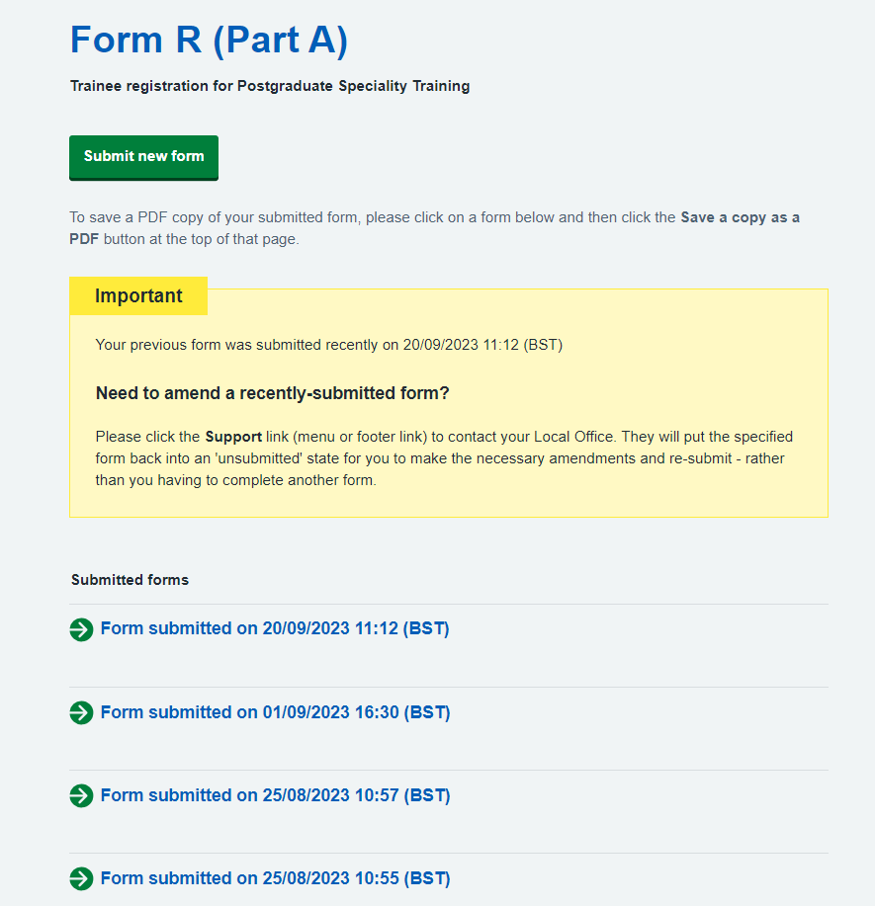
4. Form R
You will be required to complete a Form R through the Training Information System (TIS)
- Navigate to https://trainee.tis-selfservice.nhs.uk/
- Create an account using the email address we contacted you with.
- Complete and submit your Form R parts A & B

Can use TIS to submit a new form or open up and download copies of previously submitted form r’s.
Any issues please use the help button on the TIS System via the ? symbol
Information for Form R Part A:
Part A | Standard answers to input
Photo/Picture | Not required/Not applicable
Training School/NHSE Local team | Kent, Surrey and Sussex
Programme Specialty | Public Health
Specialty Awards | Not Applicable
Royal College/Faculty assessing training for the award of CCT | Faculty of Public Health
Grade | ST(relevant year)
Date Started | Should auto fill (ST1s = 07/08/2024)
Post Type or Appointment | Run Through
GMC Programme Approval Number | KSS4456
Programme Reference Number | 930

Information for Form R Part B: Please fully complete the Form B section, especially the health statement so we can support you if needed.
Part B | Standard answers to input
Current Deanery/NHSE local team | Kent, Surrey and Sussex
Current Reval date | If you are registered with the GMC, please enter your revalidation date, if not yet registered, please leave blank
Section 1 | Your details
Section 2 whole Scope of Practice | This can be left blank if first time completing a Form R for this specialty, TIS may pull in posts from previous programmes, you can select not to include them. If this is not the first ARCP, then please only select posts pulled in from TIS since your previous ARCP. These should be the posts that are being reviewed within the ARCP timeframe. i.e. ARCP from 06/06/23 - 05/06/24  Please also declare any other work such as Locums etc.
Time out of training | This can be left blank if first time completing a Form R for recruitment purposes. For ARCP purposes, please include TOOT taken. There is a 14-day allowance for TOOT before CCT date is affected. If more than 14 days TOOT is declared, a CCT calculator will need to be submitted with your ARCP documents to update CCT date
Section 3 | Declarations relating to Good Medical Practice
Section 4 | update to previous form, this can be blank
Section 5 | new declarations, this can also be left blank/ or declare I do not have anything new to declare.
Section 6 | compliments, any positive feedback you have received
Trainee Self-assessment & Declaration during COVID 19 Pandemic | Not applicable
Section 7 | Please ensure this is signed

5. Pre ARCP meeting summary
As soon as you receive your invite, please ensure you get in touch with your TPD to arrange a pre-ARCP meeting to be held about 3-4 weeks before the ARCP, after the ES reports are available. The TPD’s have a checklist to go through with you, to ensure you have all documents in place, or what else may be needed.
Please ensure you have your forms uploaded as much as possible to the E-Portfolio in time for the pre-meet, then the pre-meet form can be uploaded and added to your Documents.
6/7. Extra forms - TOOT & CCT calculator
See invitation list for information.
Documentation Storage
To store your documents please go to the personal library and save your forms using the following naming conventions:
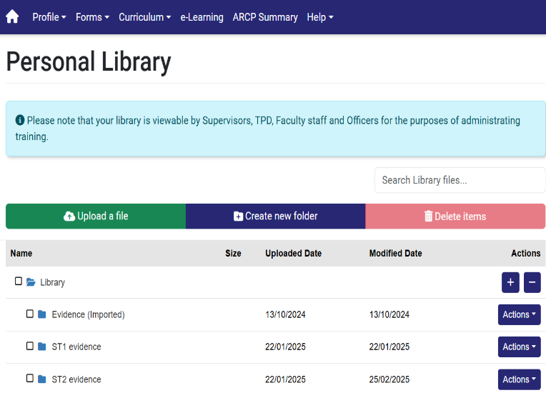
1. ES report_[placement name/location]_Initials_Mnth/year
2. LA form_[placement name/location]_Initials_Mnth/year
3. LO grid_Initials_year
4. TIS self-services_Form R Part [A/B]_Initials_year
5. Pre-ARCP meeting_Initials_year
6. CCT calculator_Initials_year (only needed if any changes made to training affecting first given CCT date such as maternity, sickness etc.)
7. ‘Time out of training’ declaration form_Initials_year (only needed of more time than allowance needed)
  - Adding forms to your ARCP
Once your forms are added to your personal library, to make them available for your ARCP you need to link them to an additional documents form. Find this through the ARCP forms tab.
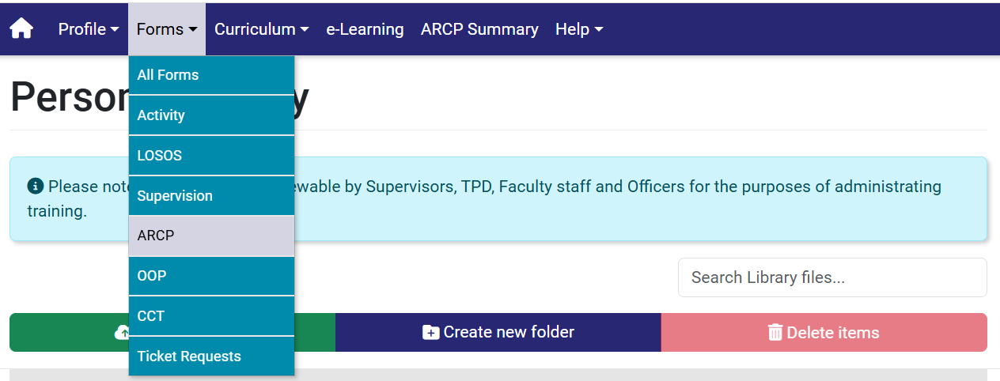
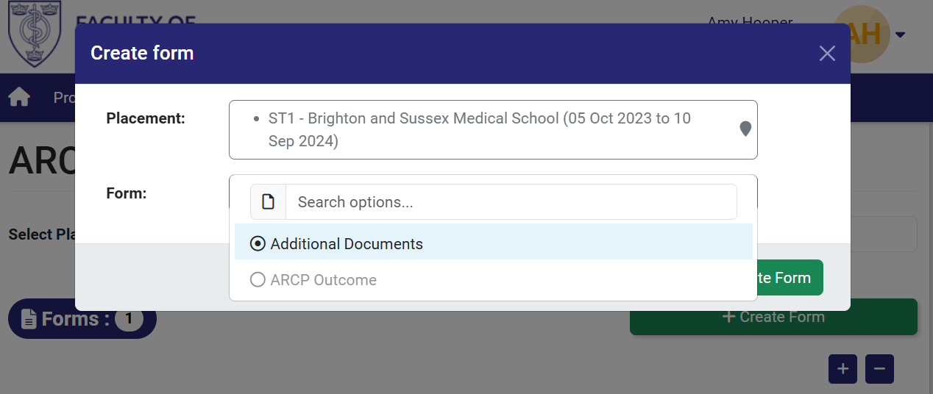
All forms should be added to a single additional documents form in the following order:
1. ES report_[placement name/location]_Initials_Mnth/year
2. LA form_[placement name/location]_Initials_Mnth/year
3. LO grid_Initials_year
4. TIS self-services_Form R Part [A/B]_Initials_year
5. Pre-ARCP meeting_Initials_year
6. CCT calculator_Initials_year (only needed if any changes made to training affecting first given CCT date such as maternity, sickness etc.)
7. ‘Time out of training’ declaration form_Initials_year (only needed of more time than allowance needed)
  - Finally…
Email Claire to state that you have completed and uploaded your ePortfolio forms.

During ARCP
The Panel Set up
The ePortfolio will allow the school to create a ARCP panel and invite panel members and StR’s into the panel creation. This should allow panel members access to view the trainee documents associated to the ARCP only, even if the panel member is outside of the trainee area. They will not be able to view any other parts of the ePortfolio.
The ARCP should consist of 1 TPD, at least 1 preferably 2 educational supervisors with ARCP training, 1 external panel member ( usually a TPD or ES from another region) and 1 lay representative.
The panel will usually follow the below procedure to review documents and give an outcome.
Check the Timetable and ARCP checklist spreadsheet for any Form R issues or other concerns. The checklist in this instance is the document created by the PSM prior to the ARCP to flag any issues, so the ARCP’s can run smoothly. This will also give the PSM time to contact the StR before the panel if they have any queries with the documents submitted.
Review Form R A&B and record TOOT
Review the Educator Supervisor reports
Complete the Educator Supervisor feedback – this is submitted to the quality team for checks, and they then decide to feedback to the ES if needed.
Review the Learning Agreement form
Check learning outcome grid
Review CCT calc if appropriate – only needs checking if had any time out of programme i.e. sick leave/parental leave/OOP
Complete Outcome form

Post-ARCP checklist
FPH: Completion of training – Applying for Recommendation for CCT
For your final ARCP the outcome form looks slightly different,
- All placements details that the Registrar has attended during training will be entered on the final ARCP (outcome 6) form. The Faculty will then accept that as the full and accurate list of placements for the trainee, superseding preceding ARCP forms.
- If this is not possible, a letter listing all placements (Start date, end date, WTE etc) for the Registrar, signed by TPD/HOS will be accepted as the final list of placements for the Registrar.
Receiving Outcome Email
You should receive an outcome email within 48 hours (2 working days) of the panel. You will be asked to review the outcome to check you agree with the information within the outcome form.
Please can I ask that this is reviewed, and signed, This can be done through ePortfolio by going to the outcome form.

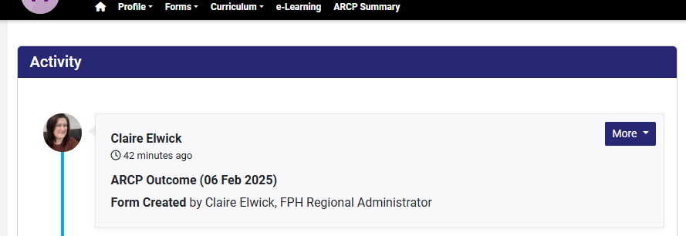
Go to more, and select open form.
At the bottom you will see
Select links, this will open up a separate box, from the drop down select signature.
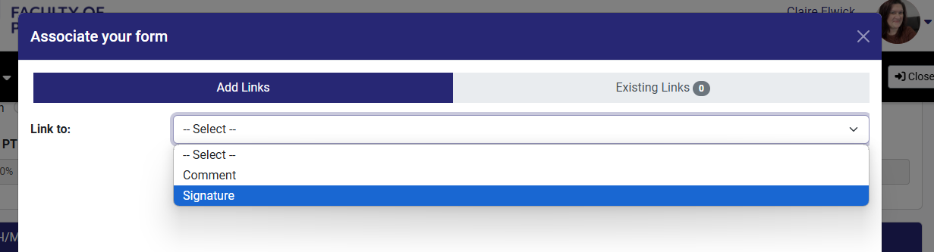

This should then give you an option to sign as yourself. If you have any difficulties with the signing of the form please let the Programme support manager know.

ARCP Outcomes
Satisfactory Progress
- Achieving progress and competences at the expected rate
Unsatisfactory progress. If you recommend one of these outcomes, you must provide reasons ("U" codes) why.
(Details must be provided on supplementary sheet overleaf. The panel must also meet with the trainee.)
- Development of specific competences required – additional training time not required
(PROVIDE REASONS OVERLEAF)
- Inadequate progress by the trainee – additional training time required
(PROVIDE REASONS OVERLEAF)
- Released from training programme with or without specified competences
(PROVIDE REASONS OVERLEAF)
Insufficient evidence (Details provided on supplementary sheet overleaf.)
- Incomplete evidence presented – additional training time may be required
(PROVIDE REASONS OVERLEAF– No U code)
Recommendation for completion of the training programme (core or higher)
- Gained all required competences for the programme
Outcomes for trainees out of programme or not in run-through training
7.1 Satisfactory progress in or completion of the LAT / FTSTA placement
7.2 Development of specific competences required – additional training time not required
(PROVIDE REASONS OVERLEAF)
7.3 Inadequate progress by the trainee – additional training time
(PROVIDE REASONS OVERLEAF)
7.4 Incomplete evidence presented – LAT / FTSTA placement
8. Out of programme: | Months counted towards training:

Please see the Gold Guide 10th Edition from August 2024 HERE Pg 63 – ARCP for further information and details about adverse outcomes and appeals.
If you are given an outcome 5, don’t panic, this is a holding outcome. This usually just means some information such as an ES report is missing or not complete. An outcome 5 gives a further 2 weeks for documentation to be submitted, when the panel will re-review missing documentation to give to full outcome. The outcome email will give full information of what is missing or what is needed and how to supply it and by when.

