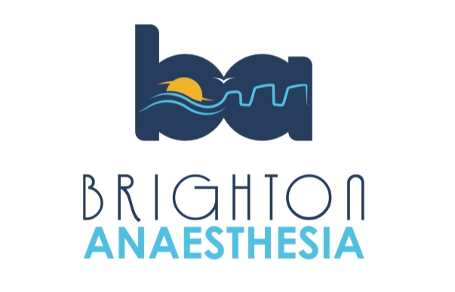
Brighton Anaesthetic Crisis Resource Management Simulation Day 2026
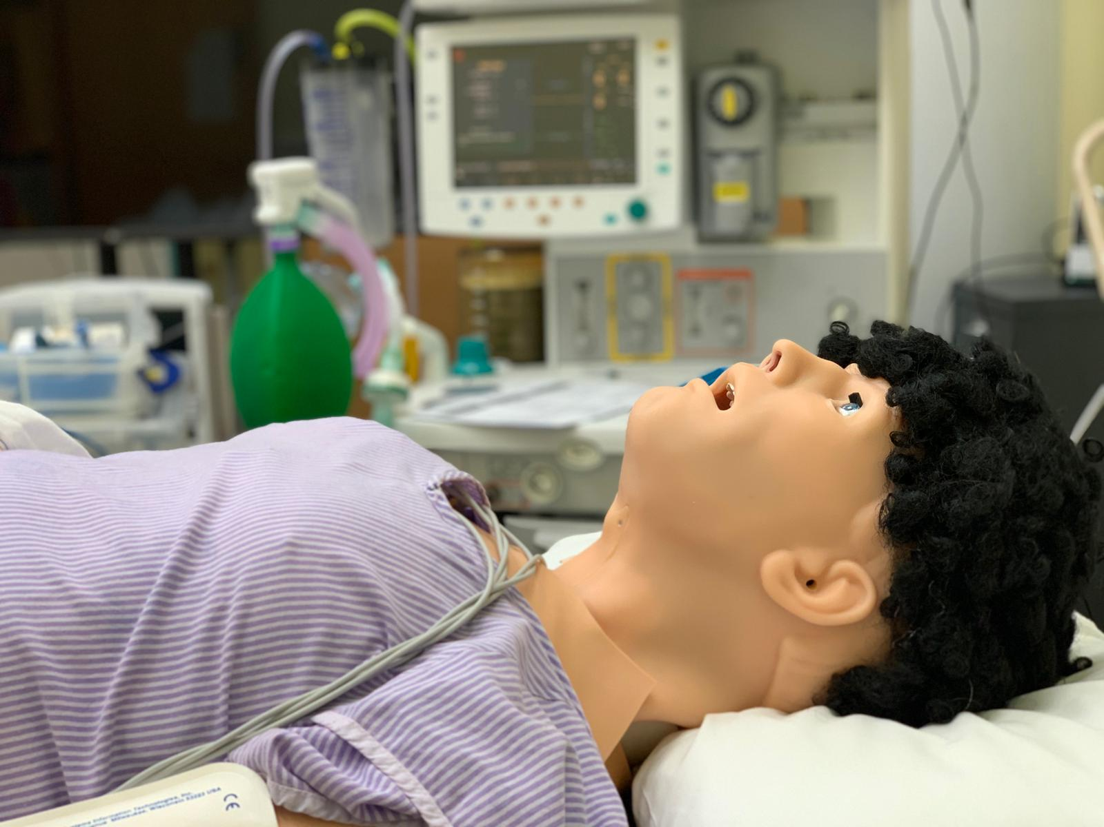
- “Ready for Reg” Simulation Day for KSS CT2s in Anaesthetics (priority to Sussex trainees)
- High Fidelity scenarios, small groups (6 candidates for each day), Experienced Faculty and ODP, CRM/Human Factors focus, Airway Workshop, Lunch and refreshments.
- Please only book 1 day:
  - Wednesday 29th April 2026
  - or
  - Friday 1st May 2026 (Approx timings: 0830-1630)

- Simulation Suite. Level 11 Louisa Martindale Building, Royal Sussex County Hospital, Brighton.
- £170 payment needed to secure place please email: simon.finn@nhs.net to check availability for preferred day and get payment link.

