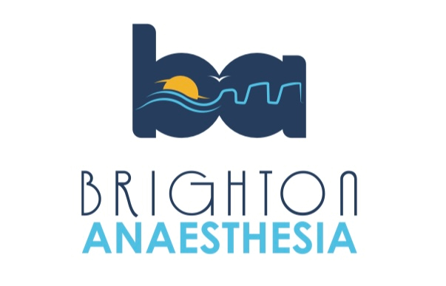
Brighton Anaesthetic Crisis Resource Management Simulation Day 2025
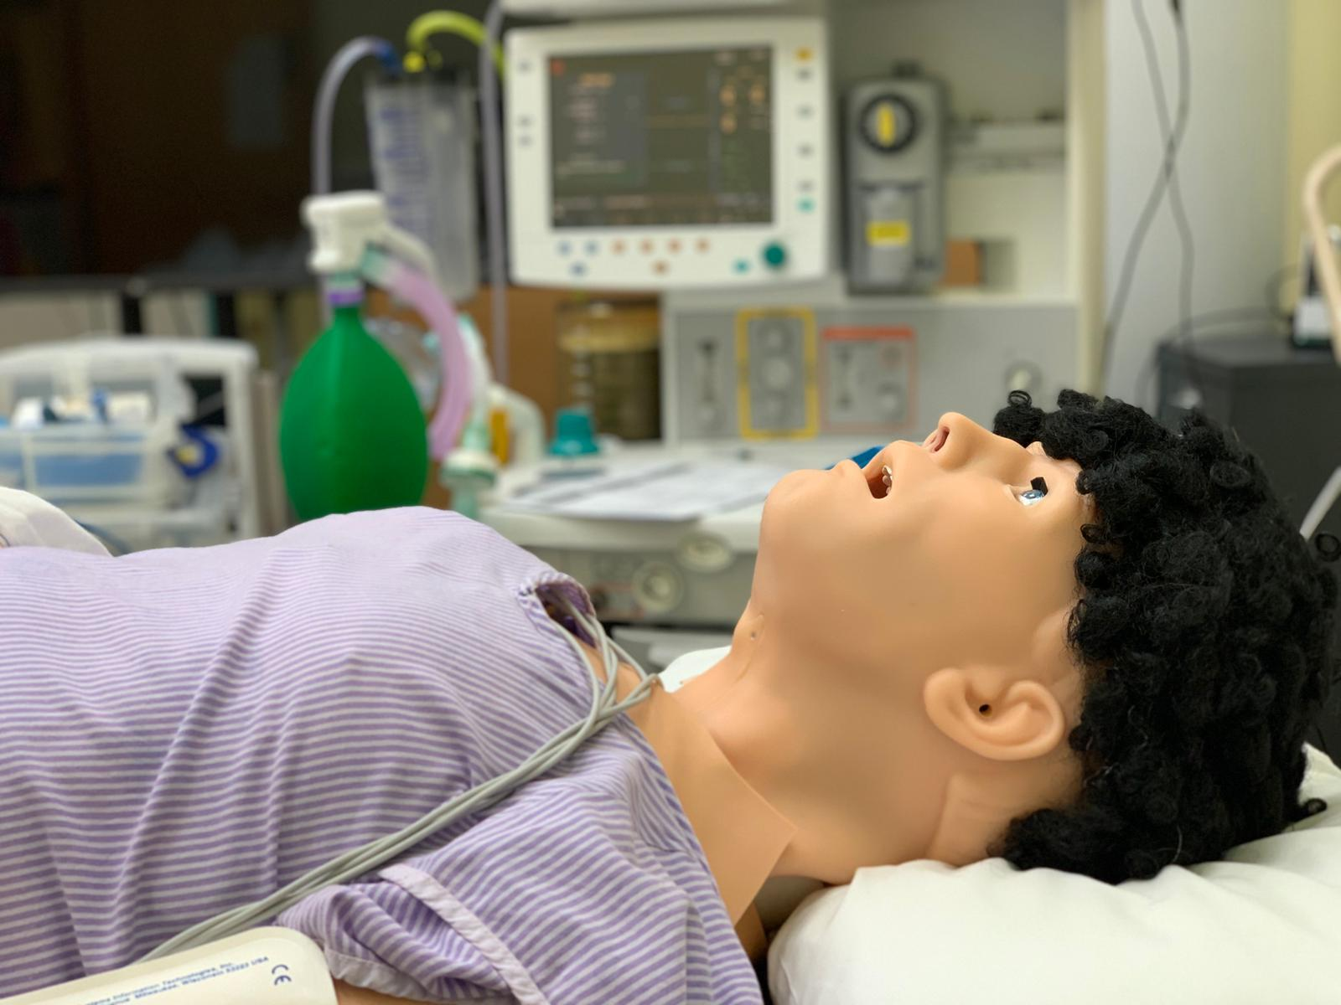
- “Ready for Reg” Simulation Day for KSS CT2s in Anaesthetics (priority to Sussex trainees)
- High Fidelity scenarios, Small groups (6 candidates for each day), Experienced Faculty and ODP, CRM/Human Factors focus, Airway Workshop, Lunch and refreshments.
- Please only book 1 day:
  - Wednesday 21st May 2025
  - or
  - Thursday 22nd May 2025 (Approx timings: 0830-1630)

- Simulation Suite. Level 11 Louisa Martindale Building, Royal Sussex County Hospital, Brighton.
- £170 payment needed to secure place and email: simon.finn@nhs.net
- Bank Details: Name: New Anaesthetic Postgraduate Education Trust
Sort Code: 40-52-40 A/C 00028864
Please Reference with ACRM25name

