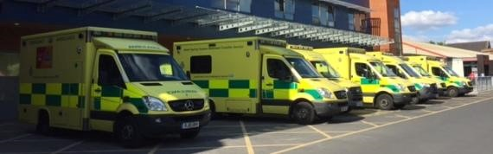

**HEKSS Regional Training Day for HST EM Tuesday 19th  November 2024**

------------------------------------------------------------------------------------------------------------------------------------

You are invited to attend the forthcoming practical procedures training day, on Tuesday 19th November 2024, in the Common Room, Postgraduate Centre at Medway Maritime Hospital.

Face-to-face teaching only. Not online.

------------------------------------------------------------------------------------------------------------------------------------

|  |  |  |
| --- | --- | --- |
| 08:45 - 09:00 | **Welcome and tea and coffee** | |
| 09:00 - 09:15 | **Introduction** | |
| 09:15 - 12:15 | **Small group practical sessions** | |
| 12:15 - 13:00 | **Lunch (provided)** | |
| 13:00 - 16:00 | **Small group practical sessions** | |
| 16:00 | **Closing remarks and feedback** | |
| |  | | --- | | **Practical sessions:**  Front of neck access  US guided fascia iliaca block  Lateral canthotomy  Resuscitative hysterotomy  Neonatal resuscitation  Emergency thoracotomy | | | |  | | --- | | **Faculty includes:**  Dr Anota (EM Cons)  Dr Choudhury (EM Cons)  Mr Da’Costa (EM Cons)  Dr Morrice (EM Cons)  Dr Okeke (EM Cons)  Dr Owolabi (ED Cons)  Dr Sa’adedin (EM Cons)  Dr Sadun (EM Cons)  Dr Shah (Anaesthetic Cons)  Dr Tolat (ED Cons)  Dr Tsolov (ED Cons) | | |

Emergency Department, Medway NHS Foundation Trust, Gillingham, Kent ME7 5NY