**ACCS Regional Training Day 2024-25**

**Resuscitation Masterclass**

**Presented by EKHUFT EM Academy**

**Venue: Medical Education Centre, William Harvey Hospital, Ashford, Kent**

**Date: 26nd Sept 2024**

**Co-Chair by Dr J Leung & Dr Elena Harry**

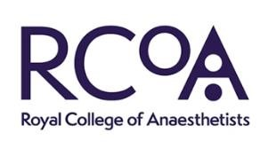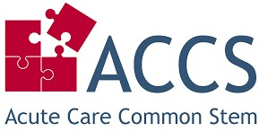

|  |  |
| --- | --- |
| **Time** | **Session** |
| 13:30– 14:15 | **High risk ECG**  **Dr Obaid**  **Dr Obaid’s Practical ECG course- Director** [**https://www.practicalecgcourses.com/home**](https://www.practicalecgcourses.com/home) |
| 14:30-15:15 | **In case for an Emergency**  **Dr Shweta Mishra**  Consultant in EM, EKHUFT |
| 15:15 – 15:30 | **BREAK** |
| 15:30 – 16:15 | **Airway management in Critically unwell**  **Dr Will Sloper** Anaesthetic SpR |
| 16:15 – 17:00 | **Sepsis 101**  **Dr Koteswara Botla**  ST6 in Emergency Medicine |
| **17:00 onward – Social** | |

|  |  |
| --- | --- |
| **Time** | **Session** |
| 09:00 – 09:30 | **Registration & Opening Remark**  **Dr Jon Leung**  Consultant in Emergency Medicine &  ICM & PHEM, ACCS /EM Trust Lead/ ACCS [EM] TPD, Honorary Senior Clinical lecturer, KMMS clinical lecturer |
| 09:30– 10:15 | **Shock**  DO2VsVO2  Macrocirculation Vs Microcirculation  **Dr Salman Naeem**  Consultant in Emergency Medicine |
| 10:15 – 11:00 | **Echo Guided Resuscitation**  **Dr Lagath Wanigababu**  ST5 in Emergency medicine |
| 11:00 - 11:30 | **BREAK** |
| 11:30 – 12:15 | **Resuscitation in Obstetric emergency**  **Dr Mia Sheikh**  Anaesthetic SpR |
| 12:15– 12:45 | **Time to be Critical……**  **Dr Ai Ru Lee, Dr Osada Suraweera**  ST5 in Emergency Medicine, ST6 in EM |
| 12:45-13:30 | **LUNCH** |

**Sponsor by:**

