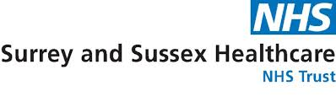
ACCS Regional Training Day
22nd February 2024
Platform: Hybrid (MS Teams & face-to-face for local county trainees)
PROGRAMME
Time | Topic | Speaker
0850-0900 | Introduction
0900-0930 | Principles of Audit | Miss Vesna Hogan  (Senior clinical audit & governance facilitator)
0930-1030 | Essentials of Critical Appraisal | Miss Alison Mclaren &  Mr Adam Black well (SASH library team)
10:00-11:00 | Complex Workplace | Dr Iuliana Clark  (Emergency medicine consultant)
11:00-11:15 | Coffee Break
11:15-12:00 | Writing a Police Statement | Trust lawyers (CapSticks Law firm)
12:00-12:30 | Realities of Quality Improvement Projects | Dr Kamal Veeramuthu  (Emergency medicine consultant)
12:30-12:50 | Review of DOACs for A&E Clinicians | Mr Tony Toma (Key account manager-AstraZeneca)
12:50-13:30 | Lunch
13:30-14:15 | Managing Complaints | Mr Farai Addy (SASH risk & governance lead)
14:15-14:45 | Trainee presentation | Dr Sophie Mustoe (Emergency medicine ST3 spR)
14:45-15:00 | Coffee Break
15:00-15:45 | Vascular Access Teaching & Ultrasound-guided Access | Dr Satrajit Dawn-ICM senior spR  Dr Gareth Ennew-Emergency medicine & ICM consultant
15:45-16:00 | Emergency Medicine Trainee Business
1600 | Close

:55

