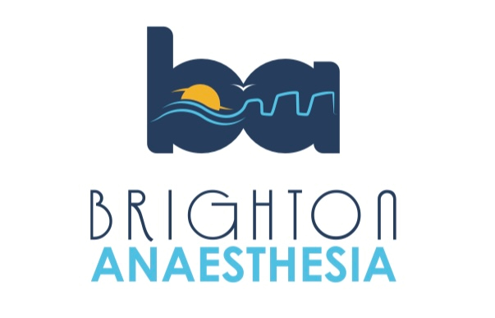
Brighton Anaesthetic Crisis Resource Management Simulation Day 2024
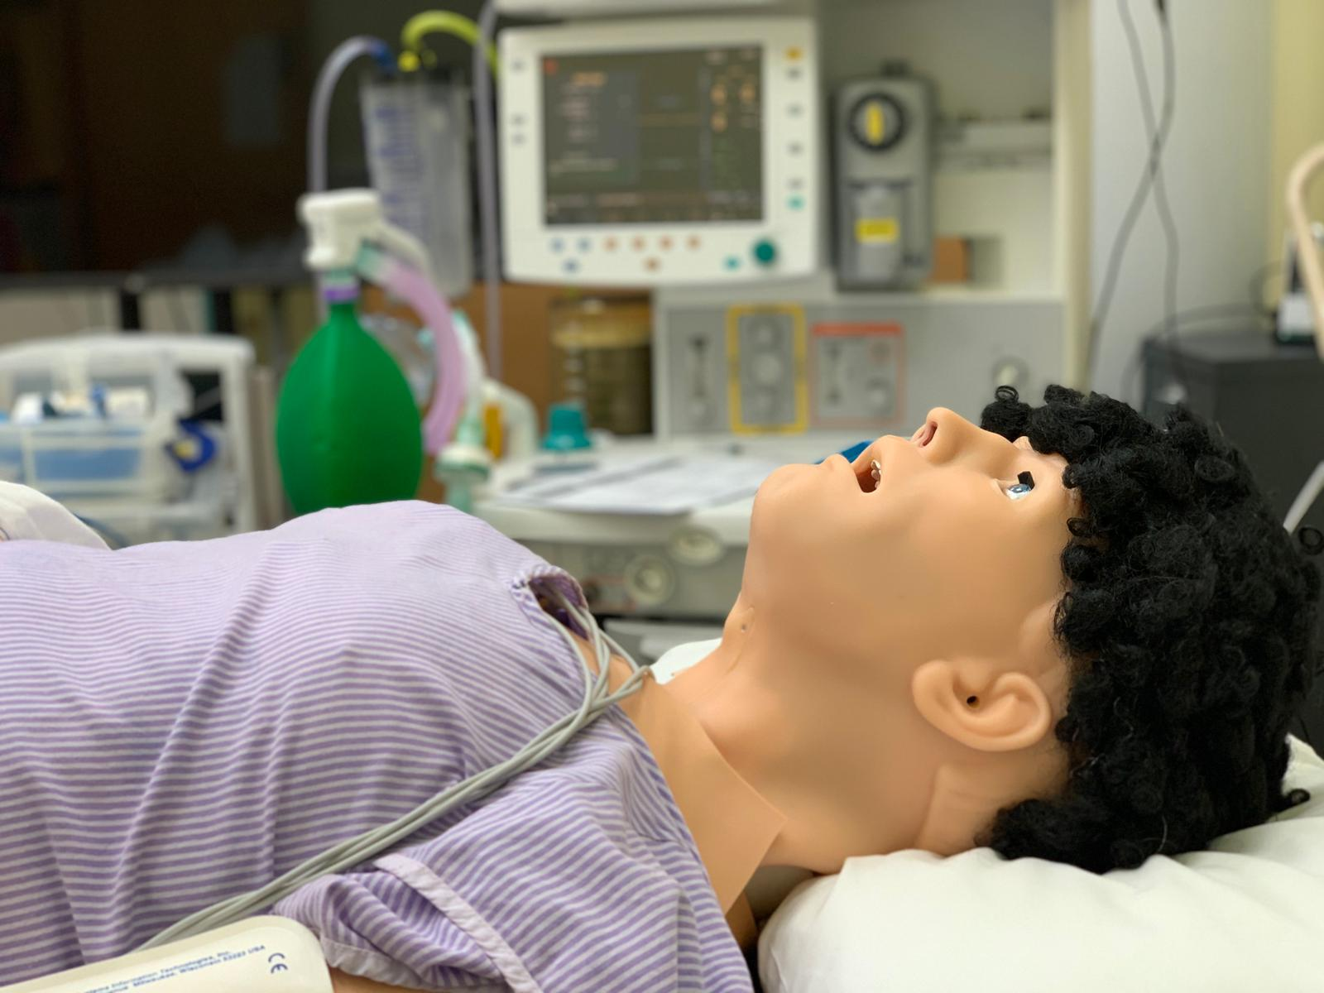
- “Ready for Reg” Simulation Day for KSS CT2s in Anaesthetics (priority to Sussex trainees)
- High Fidelity scenarios, Small groups (6 candidates for each day), Experienced Faculty and ODP, CRM/Human Factors focus, Airway Workshop, Lunch and refreshments.
- Please only book 1 day:
  - Monday 13th May 2024
or
  - Tuesday 14th May 2024
(Approx timings: 0830-1630)
- Euan Keats Education Centre, Princess Royal Hospital, Haywards Heath.
- To secure place please email: simon.finn@nhs.net

