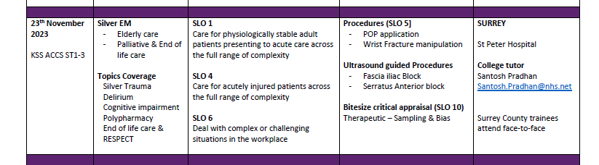
23 Nov 2023 ACCS RTD St Peters Hospital PGEC Blue room
8:30-9:00 | Coffee and registration
9:00-10:00 | Cognitive impairment- Delirium, Comprehensive geriatric assessment | Emma Wilkinson Consultant Elderly care, ASPH
10:00-10:30 | Polypharmacy in Elderly ED visit | NKetia/ Aby, Pharmacist GSM
10:30-10:45 | Coffee break
10:45-11:30 | Silver Trauma pathway/guidelines  Elderly “minor trauma series” | Santosh Pradhan EM consultant
11:30-12:45 |  | Catherine Macfarlane EM ST3
12:45-13:30 | Lunch
13:30-14:30 | POP application | Dean Funk & team, Clinical Practice Educator
14:30-15:30 | EoL Palliative care RESPECT | Joseph Hawkins  Consultant in Palliative Medicine
15:30-1600 | trainee discussion + feedback

