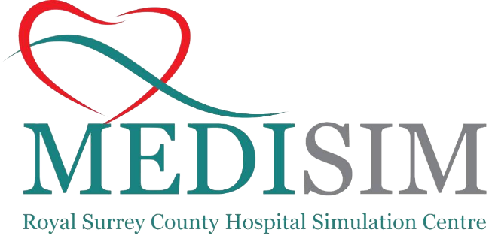

**N**ovice

**A**naesthetic

**T**rainee

**S**imulation

Novice Anaesthetists from KSS Surrey (Open to Kent/Sussex depending on availability)

(Core Anaesthetic CT1 or ACCS CT2)

**When is it?**

Three available dates:

Monday 13th November 2023 (2 spaces left)

Tuesday 14th November 2023

Wednesday 15th November 2023

**Where is it?**

Email [simfellow.rsch@gmail.com](mailto:simfellow.rsch@gmail.com) to book your place. Please provide name, base hospital and dietary requirements

**How do I book a place?**

**What is it?**

A one day course to provide experience and improve confidence in novice anaesthetists as they progress to having on call responsibilities

Course Directors

**Any enquires to be direct to simfellow.rsch@gmail.com**

Simulation Suite, Education Centre,

Royal Surrey County Hospital, Guildford

**Who is it for?**

Dr Louisa Chrisman (Cons Anaesthetist & Speciality Simulation Lead for Anaesthetics)

Dr Michele Bossy (Cons Anaesthetist & Trust Lead for Simulation)