Health Education Kent, Surrey and Sussex

GP Supervisor

(Clinical or Educational Supervisor)

Annual Peer Appraisal and PDP

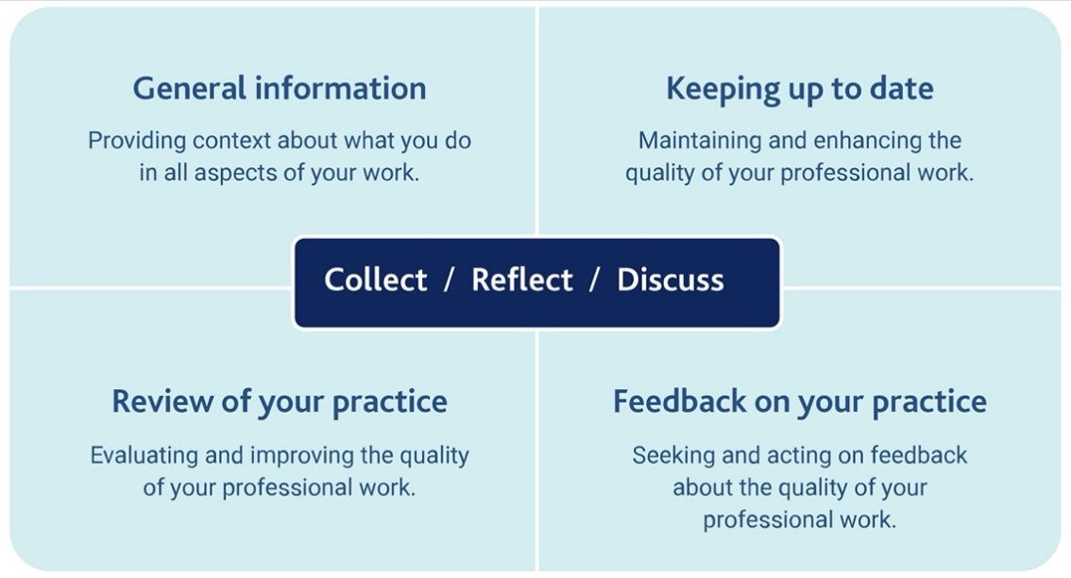

Introduction:
The GMC (2018) sets out requirements for the supporting information licensed doctors must collect, reflect on and discuss at appraisal for revalidation. You must declare all the places you have worked and the roles you have carried out as a doctor since your last appraisal, and should collect supporting information that covers the whole of this practice. It also sets the standards for training and education, stating that educators are responsible for engaging positively with training, support and appraisal relating to their role, and are accountable for the resources they receive to support education and training (GMC, 2020).
The Professional Development Framework for Educators maps to the standards and guidance for education and training developed by the healthcare regulators and provides overarching principles to guide professional development of educators and help them demonstrate the skills, knowledge and behaviours required in their role (HEE, 2017). This form is designed to assist our GP supervisors in reflecting on their performance as an educator and to consider their developmental needs and is based on the HEE framework.

Undertaking a Peer Appraisal:
Peer appraisal should be conducted with an individual who is an accredited HEE KSS GP educator (CS to CS or ES to ES), or a Programme Director from your local area. You are responsible for seeking annual appraisal, but the Programme Directors will support the process and may, if needed, facilitate pairings.

Please use the tables below to reflect on the seven key areas of activity relating to the role of an educator.
You do not need to reflect on every area each year but ensure that all areas are covered within a five-year revalidation and re-accreditation cycle.
The areas you focus on may vary according to circumstance, feedback, personal reflection on performance and your PDP.

Consider the evidence you may wish to provide to support your appraisal discussion, examples and the linked area are given below:

1-7 | Courses attended, F2F, Webinars, Meetings | 1-7 | GMC Trainer Survey
1 | Reflection on Patient Feedback | 1 | Review of learner audit, QIP etc.
1 | Details of supervision relative to trainee competence | 1 | Induction program
2,3,5 | Details of learning programs, timetables | 3 | Reflections on methods of teaching or learning opportunities
2-7 | Trainee Feedback (online or Exit Interviews) | 2-7 | Record of educational events in your role as trainer
2-7 | Reflection on colleague / peer feedback of your teaching | 1,7 | Reflection on educational SEA
4 | Assessment of a trainee: calibrated or learning from | 5 | Reflections on a trainee with additional needs
6 | Trainee support & career guidance | 7 | Equality & Diversity training
7 | Reflection on articles or books read | 7 | Certificates obtained

As part of the appraisal process you should complete a PDP relevant to your educational role. This should be shared with the local Programme Directors (information protected by Data Protection Act) to support the planning of activities for the supervisor group for the coming year and identify any issues common across individual appraisals which may need to be addressed. Please ensure any trainee or patient details used are anonymised.

You should keep a copy of each annual peer appraisal to submit to your NHS appraiser every year and to submit with your clinical / educational supervisor re-approval every five years.

Review of Educational Activities: reflect on the past year as an educator.

What have been your achievements and successes?

What areas could be improved or have caused you difficulty and why was this?

Reflect on last year’s educational PDP. Were all objectives met?

What about your wellbeing or resilience as an educator? Any resources used or required?
The table below maps the Framework areas to the standards and guidance for education and training developed by the healthcare regulators. It should be used to reflect on your activities as an educator.

 | Framework Area | Relevant Activities | Reflection on Activities undertaken
1 | Ensure safe & effective patient care through training | How you protect patients and enhance their care through your supervision of healthcare learners in training, and how you balance the needs of your patients and service with the educational needs of your learners.
2 | Establishing & maintaining an environment for learning | How you make the clinical environment safe and conducive to effective learning for learners and others.
3 | Teaching & facilitating learning | How you work with learners to facilitate their learning:
4 | Enhancing learning through assessment | This area is about your approach to assessment and feedback
5 | Supporting & monitoring educational progress | This area is about the support you provide to learners in their progression towards completion of training and their intended career destination.
6 | Guiding personal & professional development of trainees | This area is about the support you provide to learners in relation to their personal and professional development.
7 | Continuing development as a medical educator | This area is about your own professional development as a healthcare educator.

Personal Development Plan as an Educator
You do not need to reflect on every area each year but ensure that all areas are covered within a five-year revalidation and re-accreditation cycle.

Framework Area | What educational need do I have? | How will I meet this? | What will the outcome be?
Ensure safe & effective patient care through training
Establishing & maintaining an environment for learning

Teaching & facilitating learning

Enhancing learning through assessment
Supporting & monitoring educational progress
Guiding personal & professional development of trainees
Continuing development as a medical educator

Conclusion of Appraisal

Concluding comments ~ GP Educator

Concluding comments ~ Peer Appraiser

Agreement

We the undersigned confirm the accuracy of this Peer Appraisal with due process having been followed.

Name of GP Supervisor |  | Date:
Name of Appraiser: |  | Date:

This document is not valid without the above agreement being complete.

References:
General Medical Council (2018). Guidance on Supporting Information for Appraisal and Revalidation
General Medical Council (2020). Education standards & Guidance. Promoting Excellence.
HEE (2017). Professional Development Framework for Educators

