Internal Medical Practical Skills Course
2022

Darent Valley Hospital, Dartford

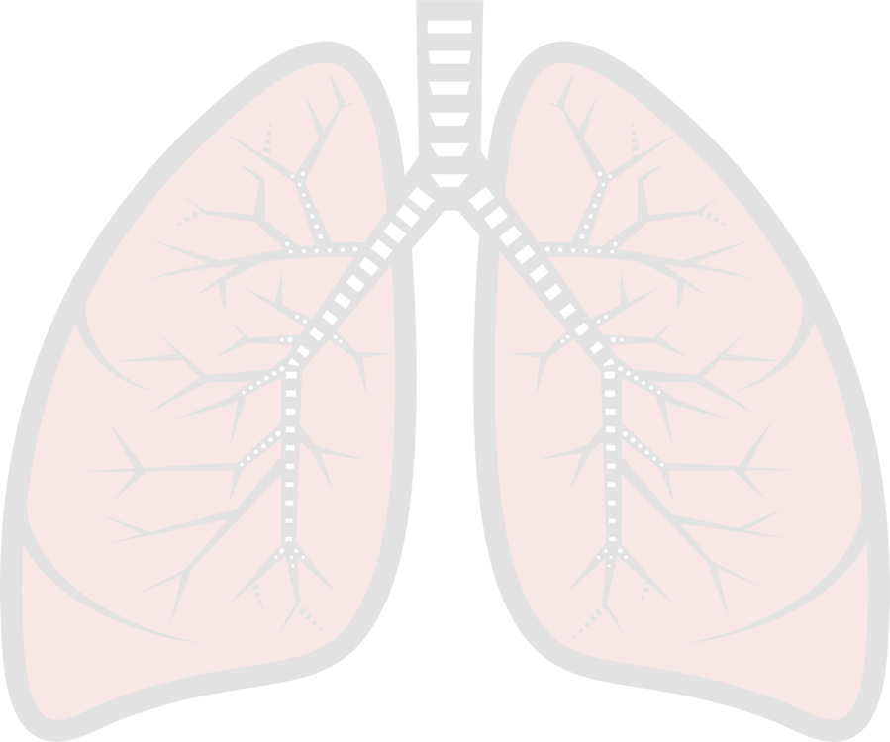
The Internal Medical Practical Skills course is designed for doctors entering internal medical training. HEKSS recognises the importance of ensuring that internal medical trainees are supported in developing key procedural skills and ensuring that they become competent and confident to perform commonly required practical procedures.

Course content:

- Non-invasive ventilation

- Pleural fluid aspiration (diagnostic / therapeutic)

- Intercostal chest drain insertion

Timetable

09:00 - 09:15 Registration
09:15 - 09:35 Introduction to NIV
09:35 - 09:50 Respiratory Failure
09:50 - 10:10 Indications & Contraindications to NIV
10:10 - 10:30 Initiating, monitoring & weaning of patients on NIV
10:30 - 12:30 Practical Sessions/Stations:
Introduction to the NIV machine and knobology
Interfaces, Circuits & Trouble shooting
Scenarios

12:30 - 13:00 Lunch

13:00 - 13:15 Introduction to Pleural Disease & Role of Ultrasound
13:15 - 13:30 Video
13:30 - 13:45 Managing Pleural Effusions
13:45 - 14:15 Managing a Pneumothorax
14:15 - 14:30 Looking after chest drains
14:30 - 17:00 Practical Sessions/Stations
Chest drain Trainer: Thoracentesis
Thoracotomy Trainer
Chest drains & Free Practice
17:00 Debrief & close
How to Apply

- Please complete the application form below and e-mail to:
Caroline Mitchell
caroline.mitchell30@nhs.net
- Due to limited space on each date, please await confirmation of your request.
- Contact details: Caroline Mitchell
caroline.mitchell30@nhs.net
01322 428100 ext. 8873
You will be sent a reminder prior to your course date with all the details herein.
Venue
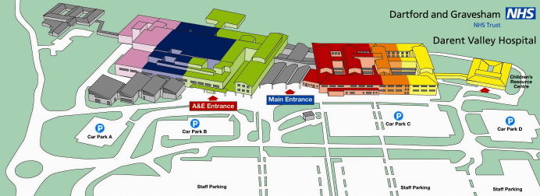
*parking office
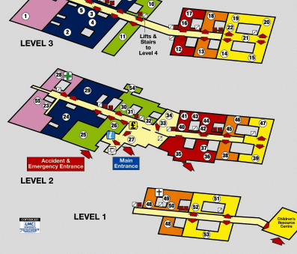

Philip Farrant Education Centre on Level 1

For more information and directions: www.dvh.nhs.uk/contact-or-visit-us/maps
Driving in? Park in Staff Car Park A and revalidate your ticket in the parking office* for £1 at the end of the day.
Internal Medical Practical Skills Course
2022

Darent Valley Hospital, Dartford

Application Form
I would like to attend the following date (select one only) :
Saturday 14th January 2023
Saturday 25th February 2023
Saturday 18th March 2023

Please PRINT throughout
Name
Grade
Hospital Name
Correspondence Address

Telephone
Email Address
Signature
Date

