Internal Medical Practical Procedures Course
2022

Darent Valley Hospital, Dartford

The Internal Medical Practical Procedures course is designed for doctors entering internal medical training. HEKSS recognises the importance of ensuring that internal medical trainees are supported in developing key procedural skills and ensuring that they become competent and confident to perform commonly required practical procedures.

Course content:

- Insertion of central venous lines under ultrasound guidance
- Ascitic fluid aspiration
- Knee joint aspiration
- Lumbar puncture
- Nasogastric tube insertion

Timetable

08:45 – 09:00 Registration
09:00- 10:00 Videos

Practical Sessions & Simulation (5 stations)

10:00 – 11:15 Station 1
11:15 – 12:30 Station 2

12:30 – 13:00 Lunch

13:00 – 14:15 Station 3
14:15 – 15:30 Station 4
15:30 – 16:45 Station 5
16:45 – 17:00 Debrief & Close

How to Apply

- Please complete the application form below and email to:
Caroline Mitchell
caroline.mitchell30@nhs.net
- Due to limited space on each date, please await confirmation.
- Contact details: caroline.mitchell30@nhs.net
01322 428100 ext. 8873
You will be sent a reminder prior to your course date with all the details herein.
Venue

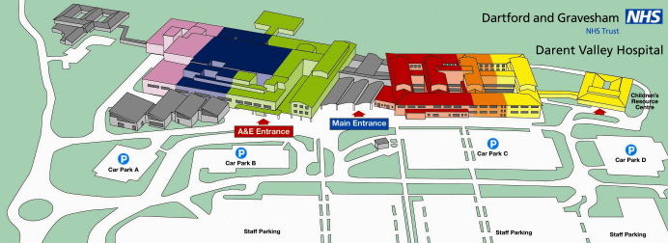
*parking office
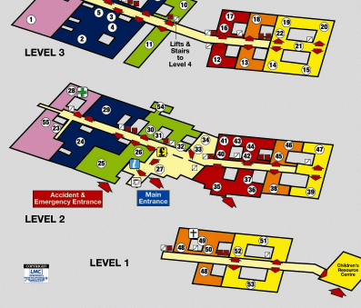

Philip Farrant Education Centre on Level 1

For more information and directions: www.dvh.nhs.uk/contact-or-visit-us/maps
Driving in? Park in Staff Car Park A and revalidate your ticket in the parking office* for £1 at the end of the day.
Internal Medical Practical Procedures Course
2022

Darent Valley Hospital, Dartford
Application Form
I would like to attend the following date (select one only) :
Saturday 15th October 2022
Saturday 12th November 2022
Please PRINT throughout
Name
Hospital Name
Correspondence Address

Telephone
Email Address
Signature

Date

