**Wessex Ophthalmic** **Practitioner Programme (OPT)**

**Newsletter 2 (September 2021)**

Welcome to the second newsletter to support the implementation of the OPT programme within the Wessex region, including information for OPT Leads, OPT learners and all staff working within ophthalmology on the latest regional activities, plans, progress, training and learning opportunities.

**Current progress with the implementation of the OPT programme (2021)**

**Registered OPT Learners (Sept 2021) Targets for the year 2021**

|  |  |  |  |
| --- | --- | --- | --- |
|  |  |  | **Unit Lead** |
| **Basingstoke Unit** | **5** |  | N. Srikantha |
| **Salisbury Unit** | **3** |  | R. Arora |
| **Southampton Unit** | **2** |  | R.Krishnan |
| **Dorchester Unit** | **2** |  | L. Howe |
| **Portsmouth Unit** | **2** |  | S. Makuloluwe |
| **Bournemouth Unit** | **2** |  | K.Bush |
| **Winchester Unit** | **1** |  | N.Srikantha |
| **Isle of Wight** |  | Nurses enrolled in foundation course | P.Moradi |
| **total** | **17** |  |  |

.

-Regional teams to support each unit to set up OPT programme

-Each Unit to support minimum 2 learners to be enrolled onto the OPT programme or Portsmouth Uni course before 31st Dec 2021

-Each unit and unit lead to set up and maintain local database for each learner

**Support for OPT learners:** First OPT Learners Rep (2021-2022) **Annabelle Searle,** Senior Orthoptist, Salisbury NHS Foundation Trust

I started working alongside the Medical Retina Consultants in the AMD clinics approximately 5 years ago, initially one session a week observing and now running my own AMD clinics (doing assessments, interpreting imaging, making clinical management decisions and consenting patients for intravitreal treatments) in semi-supervised role. In addition to performing intravitreal injections, I also train other non-medical staff members. I love the teaching aspect as this gives me new insight and responsibility in this field.

Six months ago I was encouraged to enroll onto the RCOphth Ophthalmic Practitioners Training (OPT) program in Medical Retina and Cataract. More recently, I have also been given the opportunity to act as the Regional OPT Rep. In this role I aim to help OPT learners with queries and questions about getting set up on the course and completing the portfolio. Most importantly to give all learners a collective voice, allowing everyone involved with OPT to be heard and in doing so making the process as enriching as possible for everyone.

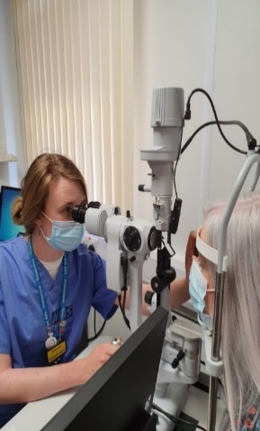

**Quarterly TEAMs meeting for OPT Leads and Learners** – to update, discuss and feedback progress

**Friday 15th October 2021 12:00 – 14:00**. Please email Chris Caws for Teams link

**New Foundation Eye Course developed by Portsmouth University**

* Pilot commenced April 2021 – 7 x Registered Nurses successfully completed the course
* Next course for nursing staff across the region is October 2021 and Spring 202- Dates TBC

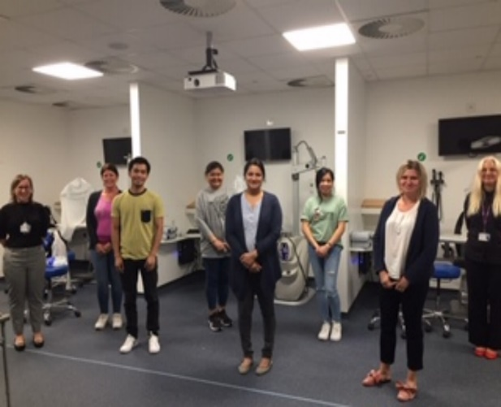

**Successful candidates (April 2021)**

**Plans for 2022**

1. Regional subspeciality Training Sessions for OPT learners.
2. Exchange Programmes.
3. Buddy sysytem.
4. Modify Foundation in Ophthalmology course for Band 4 staff.
5. Develop Glaucoma and MR courses via Portsmouth University



**New Wessex Region Teaching Programme for Ophthalmic Practitioner Training (OPT) Learners**

This training programme will be:

* A Friday half-day (1-4:30pm) once a month – dates TBC and sent out to all OPT Leads and OPT Learners
* Cover the 4 pillars of the OPT programme - Cataract, Glaucoma, MR and Eye Emergency specialities
* There will be two speciality sessions per year
* OPT Learners will be expected to complete post session self-assessment MCQ that will be emailed to the unit OPT lead

For further information on the OCCCF/OPT Programme

Health Education England web site <https://www.hee.nhs.uk/our-work/advanced-clinical-practice/ophthalmology-common-clinical-competency-framework-curriculum>

The Royal College of Ophthalmologistsweb site – type ‘OCCCF’

**Additional Regional Education and Training Events that OPT learners can access**

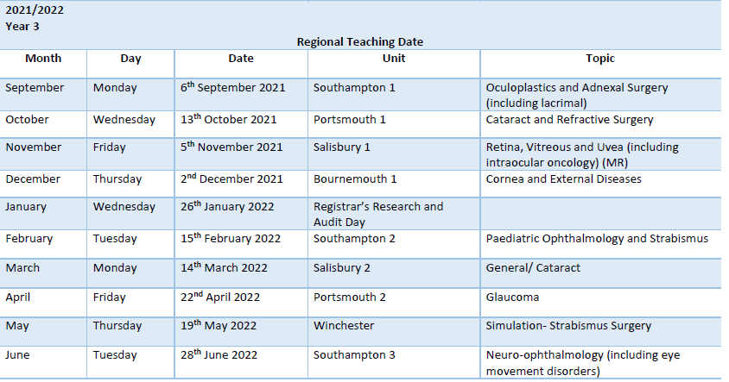

**Booking details:**

**Wessex Region Website**

**Registration needs to be 8 weeks in advance**

<https://www.wportal.co.uk/>

**Regional contact details**

|  |  |
| --- | --- |
| **Regional Education Advisor** | **Doreen Khan-Lim** [**Doreen.khanlim@uhs.nhs.uk**](mailto:Doreen.khanlim@uhs.nhs.uk) |
| **Regional OPT Lead** | **Rashi Arora** [**rashi.arora1@nhs.net**](mailto:rashi.arora1@nhs.net) |

Please send any ideas or information to be included in the next newsletter to Chris Caws

[christine.caws@porthosp.nhs.uk](mailto:christine.caws@porthosp.nhs.uk)