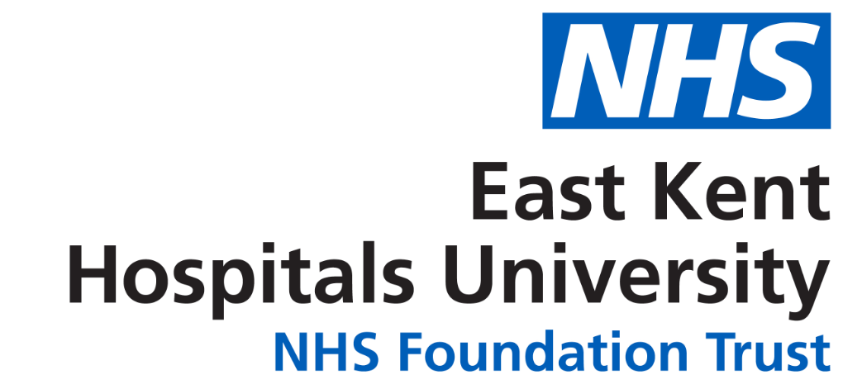
Kent Surrey and Sussex School of Anaesthesia
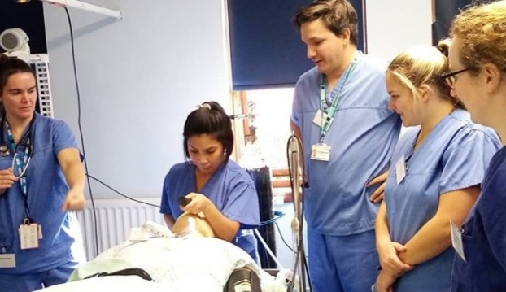
Return to Training Course

For those returning to Anaesthetic training following time away for reasons such as parental leave, a period of ill health, time away for research.
This course features workshops and simulation-based sessions to include common clinical scenarios, pre-op assessment and signposting for updated guidelines.
- Clinical Reminders
- Confidence boosters
- Informal mentoring
- Opportunities for PEER discussion and support
Course capacity 8 candidates
High delegate to faculty ratio

Date: Thursday 3th March 2022
Venue: William Harvey Hospital, Kennington Rd, Ashford, TN240LZ
Cost: £200 for non KSS/London Trainees (should be refundable from your own SuppoRTT budget)
No cost for KSS/London Anaesthetic Trainees.
Contact: Dr Nicola Somerville Nicola.somerville@nhs.net

